University Of Delhi




Ramanujan College
DSC 12 : Computer Network
Semester-04
(2024-25)

Submitted To:
~ Ms. Sheetal Singh
(Assistant Professor)
Department of Computer Science

Submitted By:
~Ratnesh Kumar
20231432(23020570034)

Acknowledgement
I would like to take this opportunity to acknowledge everyone who has helped us in every stage of this project.
I am deeply indebted to my computer science Professor, Ms. Sheetal Singh for his guidance and suggestions in completing this practical. The completion of this practical was possible under his guidance and support.
I am also very thankful to my parents and my friends who have boosted me up morally with their continuous support.
At last but not least, I am very thankful to God almighty for showering his blessings upon me.

Index
S.No | Topic | Remarks
1. | To Study Basic Network Command And Network Configuration Commands
2. | To Study And Perform PC To PC Communication Using Ethernet
3. | To Create Star Topology Using Hub And Switch
4. | To Create Bus, Ring, Tree, Hybrid, Mesh Topologies
5. | Perform An Initial Switch Configuration
6. | Perform An Initial Router Configuration
7. | To Implement Client Server Network
8. | To Implement Connection Between Devices Using Router
9. | To Perform Remote Desktop Sharing Within LAN Connection

Practical 1 : To Study Basic Network Command And Network Configuration Commands
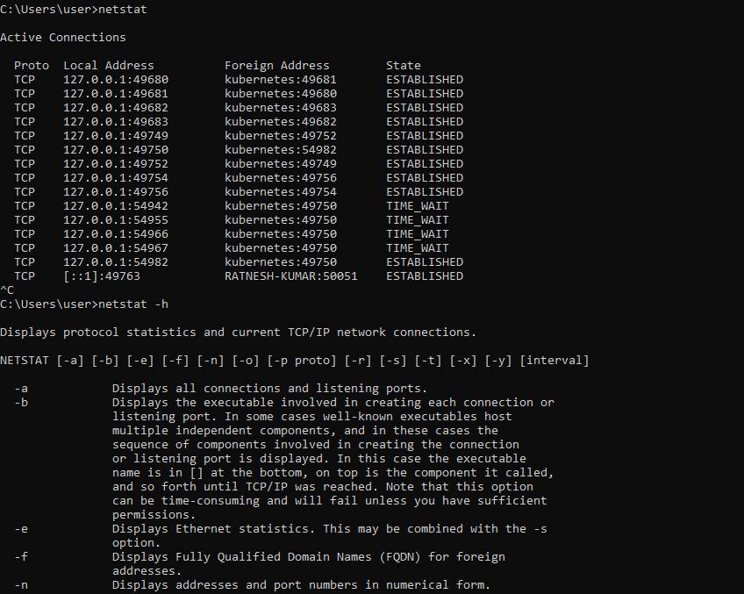
1.netstat
2.nslookup
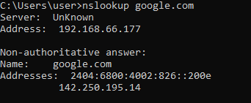
3.ping
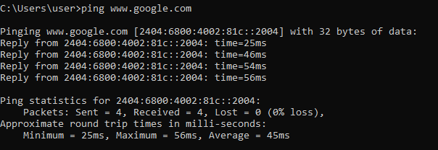
4.route
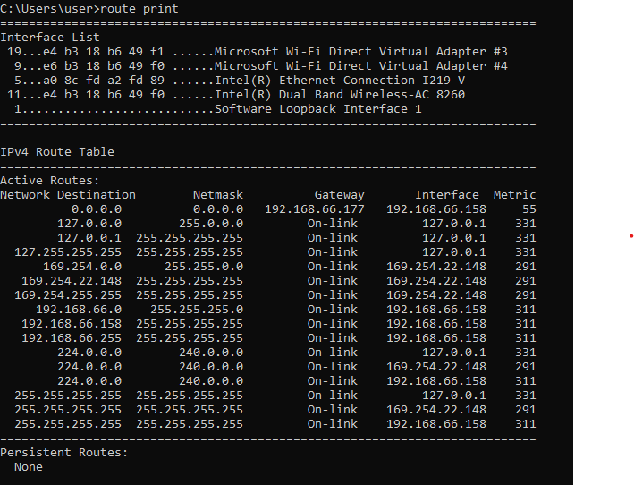
5.arp
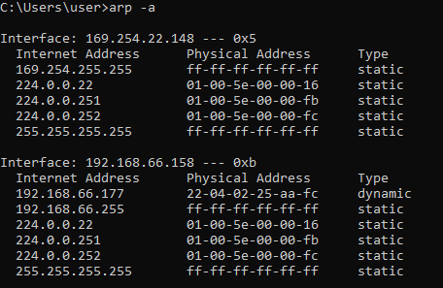
6.tracert
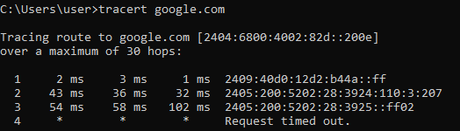
7.hostname
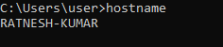

8.ipconfig
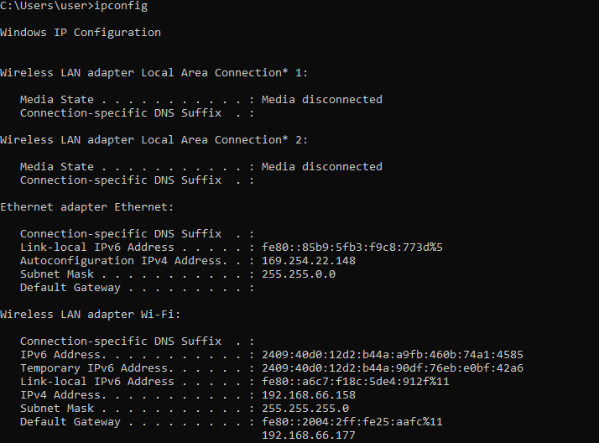
9.systeminfo
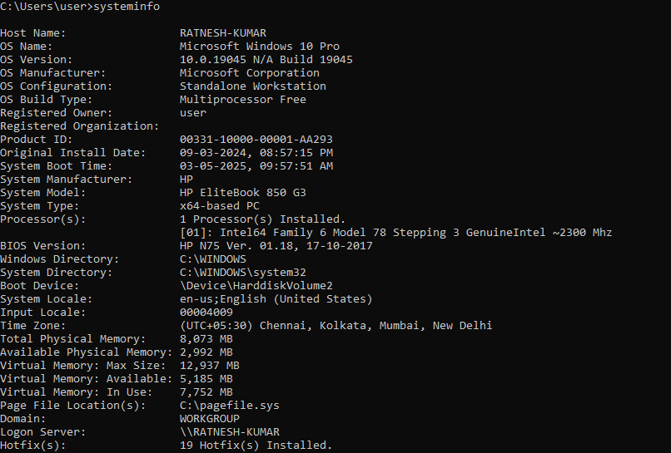
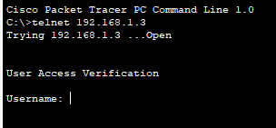
10.telnet

Practical 2 : To Study And Perform PC To PC Communication Using Ethernet.

Objective:
- To connect two PCs and ensure they can communicate using IP addresses.

Requirements:
- Two PCs

Procedure:
Step 1 : Drag two PCs onto the workspace.
Step 2 : Use a Copper Cross-Over Cable to connect them.
Step 3 : Click on each PC:
    - Desktop > IP Configuration.
    - Assign IPs like 192.168.1.1 and 192.168.1.2 with subnet mask 255.255.255.0.
Step 4 : Open Command Prompt and ping the other PC to check communication.

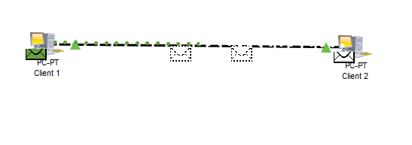
Practical 3 : To Create Star Topology Using Hub And Switch.
Objective:
- To create Star topology using Hub and Switch
Requirements:
- PCs (3 or more)
- Hub/Switch
Procedure:
Step 1 : Drag the required number of PCs onto the workspace.
Step 2 : Add a Hub and/or Switch to the center of the topology.
Step 3 : Use Copper Straight-Through Cables to connect each PC to the Hub/Switch.
Step 4 : Assign IP addresses to each PC (e.g., 192.168.1.x) using:
    - Desktop > IP Configuration.
Step 5 : Ping between PCs to verify connectivity.

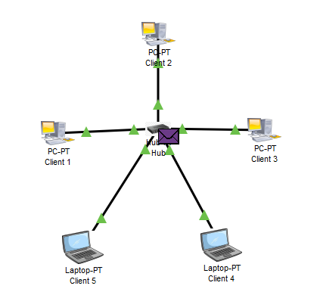
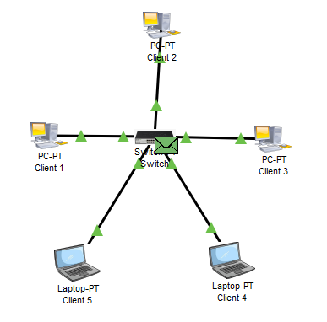
Star Topology Using Hub
Star Topology Using Switch
Practical 4 : To Create Bus, Ring, Tree, Hybrid, Mesh Topologies.
Objective:
- To create Bus, Ring, Tree, Hybrid, and Mesh topologies
Requirements:
- Multiple PCs
- Appropriate networking devices (Hubs, Switches, Routers)
- Copper Cables
- Cisco Packet Tracer
Procedure:
Step 1: Drag the required devices (PCs, Switches, Routers) onto the workspace.
Step 2: Connect the devices using appropriate cables (Copper Straight-Through or Copper Cross-Over).
Step 3: Arrange the devices to create different topologies:
- Bus: Connect all devices to a single backbone cable.
- Ring: Connect devices in a circular loop.
- Tree: Connect multiple switches in a hierarchical fashion.
- Hybrid: Combine two or more topologies to form a hybrid structure.
- Mesh: Connect every device to every other device.
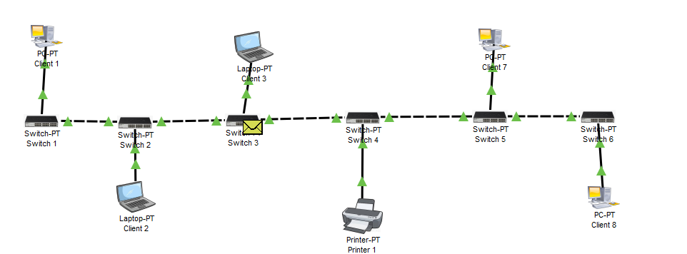
Step 4: Configure IP addresses on each device in the network and verify communication.
Bus Topology
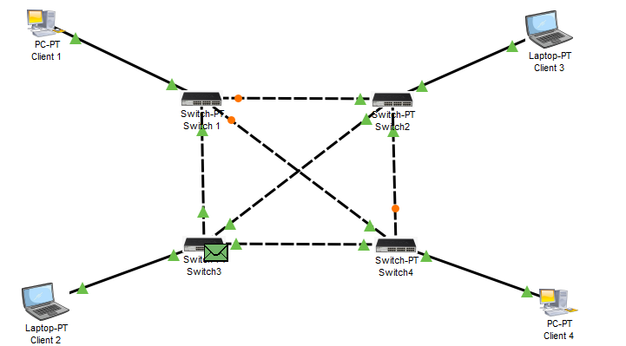
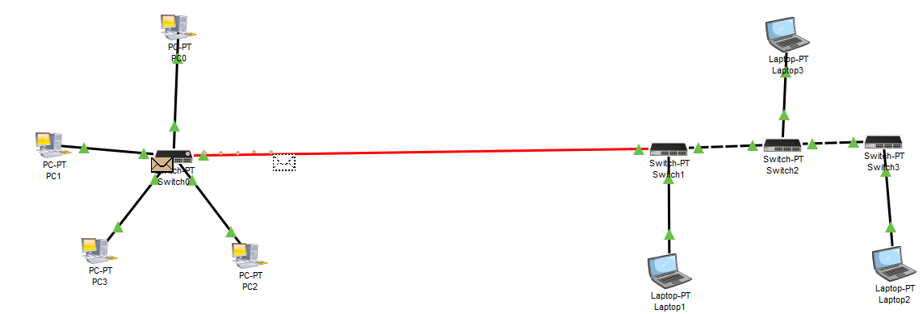
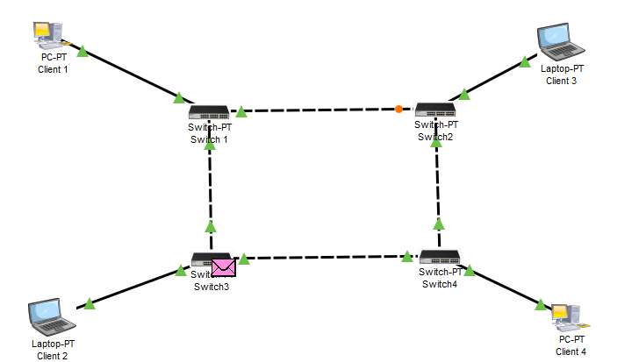
Hybrid
Topology
Bus Topology
Ring
Topology
Practical 5 : Perform An Initial Switch Configuration.
Objective:
- To perform basic initial configuration of a Cisco switch.
Requirements:
- Switch
- Multiple PCs
- Copper Cables
- Cisco Packet Tracer
Procedure:
- Drag a Switch onto the workspace.
- Connect PCs to the Switch using Copper Straight-Through cables.
- Access the Switch CLI and configure the basic settings:
Switch> enable
Switch# configure terminal
Switch(config)# hostname S1
S1(config)# enable secret class123
S1(config)# line console 0
S1(config-line)# password cisco
S1(config-line)# login
S1(config-line)# exit
S1(config)# line vty 0 15
S1(config-line)# password cisco
S1(config-line)# login
S1(config-line)# exit
S1(config)# banner motd #Unauthorized Access Prohibited#
S1(config)# interface vlan 1
S1(config-if)# ip address 192.168.1.2 255.255.255.0
S1(config-if)# no shutdown
S1(config-if)# exit
S1(config)# exit
- Save the configuration:
S1# copy running-config startup-config
- Test connectivity by pinging from a PC to the Switch’s IP address.
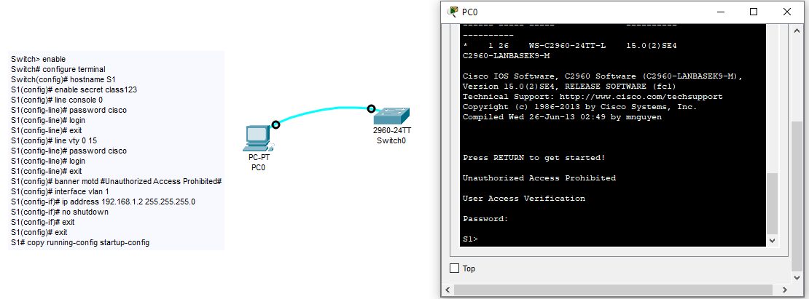

Practical 6 : Perform An Initial Router Configuration.
Objective:
- To configure a basic Cisco router with an interface IP address and enable the interface.
Requirements:
- Router
- Switch
- PC
- Copper Cables
- Cisco Packet Tracer
Procedure:
- Drag a Router onto the workspace.
- Connect the Router to a Switch and PC using Copper Straight-Through cables.
- Access the Router CLI and perform the configuration:
Router> enable
Router# configure terminal
Router(config)# hostname R1
R1(config)# enable secret class123
R1(config)# line console 0
R1(config-line)# password cisco
R1(config-line)# login
R1(config-line)# exit
R1(config)# line vty 0 15
R1(config-line)# password cisco
R1(config-line)# login
R1(config-line)# exit
R1(config)# banner motd #Authorized Access Only#
R1(config)# interface gigabitEthernet 0/0
R1(config-if)# ip address 192.168.1.1 255.255.255.0
R1(config-if)# no shutdown
R1(config-if)# exit
R1(config)# exit
- Save the configuration:
S1# copy running-config startup-config
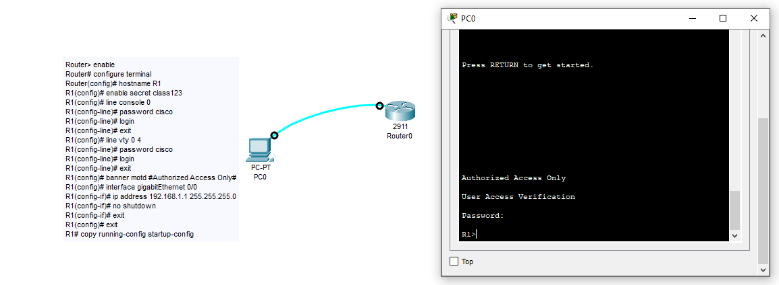
- Test connectivity by pinging from a PC to the Router’s IP address.

Practical 7 : To Implement Client Server Network.
Objective:
- To set up a client-server network and ensure communication between a client PC and a server.
Requirements:
- Multiple PCs
- Server
- Switch
- Copper Cables
- Cisco Packet Tracer
Procedure:
- Drag two PCs and a Server onto the workspace.
- Connect devices using Copper Straight-Through cables to a Switch.
- Configure static IP addresses on the Client and Server:
  - For the Client:
    - PC1: IP = 192.168.1.11, Mask = 255.255.255.0
    - PC2: IP = 192.168.1.12, Mask = 255.255.255.0
    - PC3: IP = 192.168.1.13, Mask = 255.255.255.0
  - For the Server:
IP Address: 192.168.1.10
Subnet Mask: 255.255.255.0
- Test communication by pinging the Server from the Client:
ping 192.168.1.10
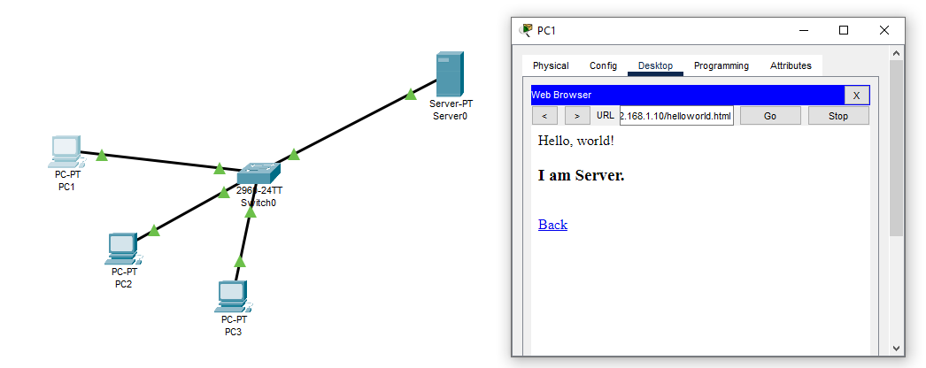
Practical 8 : To Implement Connection Between Devices Using Router.
Objective:
- To configure a router to enable communication between devices on different networks.
Requirements:
- Routers
- Switch
- Multiple PCs
- Serial cables
- Copper Cables
- Cisco Packet Tracer
Procedure:
- Drag two Routers onto the workspace and connect them using Serial cables.
- Connect PCs to the Routers using Copper Straight-Through cables.
- Configure Router interfaces with IP addresses and enable them:
  - For Router1 (gigabitEthernet 0/0):
Router(config)# interface g0/0
Router(config-if)# ip address 192.168.1.1 255.255.255.0
Router(config-if)# no shutdown
Router(config-if)# exit

  - For Router2 (gigabitEthernet 0/1):
Router(config)# interface g0/1
Router(config-if)# ip address 192.168.2.1 255.255.255.0
Router(config-if)# no shutdown
Router(config-if)# exit

- Set up IP Address between PCs:
  - Configure Network 1 PCs:
    - PC0: 192.168.1.10, Gateway: 192.168.1.1
    - PC1: 192.168.1.11, Gateway: 192.168.1.1
  - Configure Network 2 PCs:
    - PC2: 192.168.2.10, Gateway: 192.168.2.1
    - PC3: 192.168.2.11, Gateway: 192.168.2.1
- Test communication by pinging a PC in Router1’s network from Router2’s network.
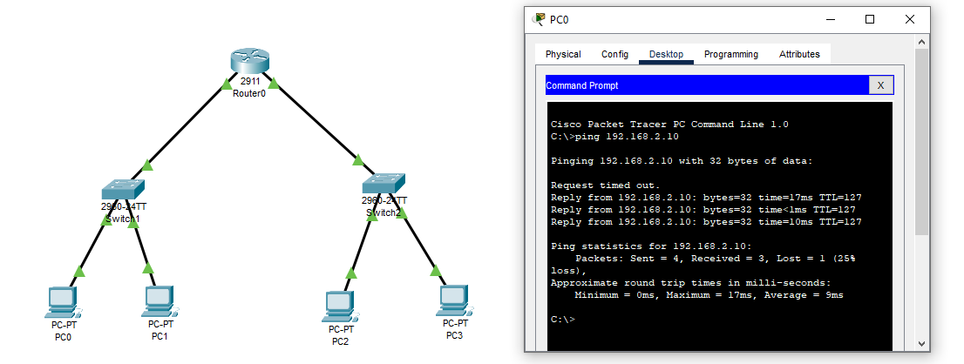
Practical 9 : To Perform Remote Desktop Sharing Within LAN Connection.
Objective:
- To set up and test Remote Desktop access between two PCs within the same LAN.
Requirements:
- Multiple PCs
- Switch
- Copper Cables
- Cisco Packet Tracer
Procedure:
- Drag two PCs onto the workspace and connect them using Copper Straight-Through cables to a Switch.
- Configure static IP addresses on both PCs:
  - For PC1:
IP Address: 192.168.1.10
Subnet Mask: 255.255.255.0
  - For PC2:
IP Address: 192.168.1.20
Subnet Mask: 255.255.255.0
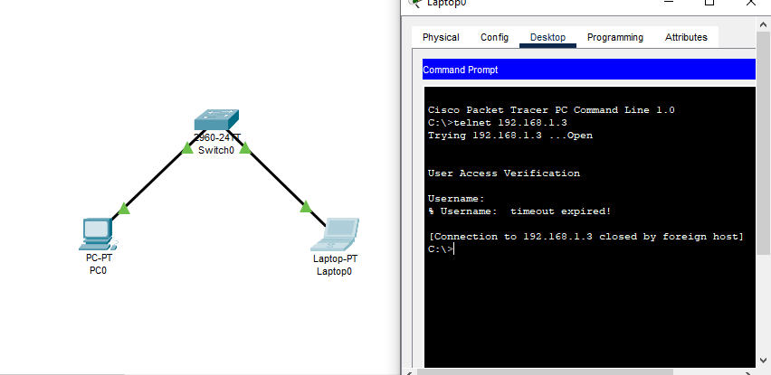
- Test the connection by logging into PC1 from PC2 via the Remote Desktop application.

